**Data Analysis Project steps**

1. create a problem statement

2. identify the data you want to analyze

3. explore and clean the data

4. analyze the data to get useful insights

Present the data in terms of a report or dashboard using visualization

**BUSINESS PROBLEM**

In recent years, city hotel and resort hotel have seen high cancellation rate. each hotel is now dealing with number of issues as result, including fewer revenues and less than ideal hotel room use. Consequently, lower cancellation rate is both hotels primary goal in order to increase their efficiency in generating revenue and for us to offer through h business advice to address this problem.

The analysis of hotel booking cancellations as well as other factors that have no bearing on their business and yearly revenue generation are main topic of this report.

*Hotel pic*

**ASSUMPTIONS**

**1.NO unusual occurrences between 2015 and 2017 will have substantial impact on the data used.**

**2.the information is still current and can be used to analyze a hotel possible plan in efficient manner**

**3.there are no unanticipated negative to hotel employing any advised technique**

**4.the hotel are not currently using any of suggested solutions**

**5.the biggest factor affecting the effectiveness of earning income is booking cancellations**

**6.cancellation result in vacant rooms for booked length of time.**

**7.Clients make hotel reservation the same year make cancellations.**

**RESEARCH QUESTIONS**

1.What are the variable that affect hotel reservation cancellations?

2.how, can we make hotel reservation cancellation better?

3.how will hotel be assisted in making pricing and promotional decisions?

**HYPOTHESIS**

1.more cancellation occur when price is higher.

2.when there is longer waiting list customer tends to cancellation more frequently

3.the majority of clients are coming from offline travel agents to make their reservation.

***ANALYSIS AND FINDINGS***

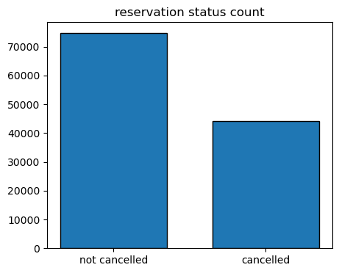***1. graph one reservation status***

The accompanying bar graph shows the percentage of reservations that are cancelled and those that are not .it is obvious that there are still significant number of reservation that have been canceled. There are still 37% of clients who canceled their reservation which has significant impact on hotels earnings.(0.67 -not cancelled 0.37 cancelled)

***2. reservation status in different hotel***

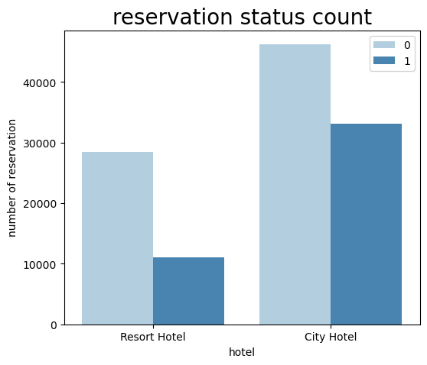

In comparison to resort hotels, city hotel have more booking it’s possible that resort hotels are more expensive that those in cities.

***3. average daily rate in city and resort hotel***

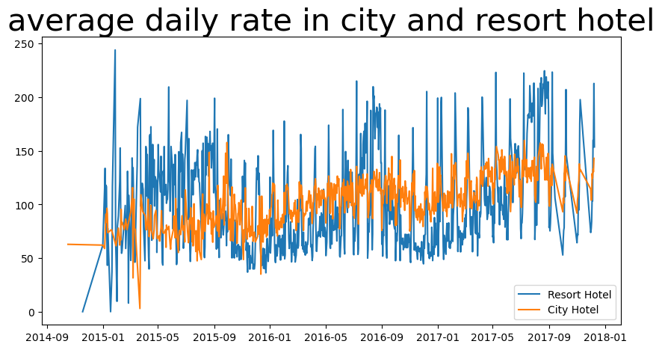

The line graph above shows that on certain daily’s average rate for city hotel is less that of resort hotels and on other days it is even less. It goes without saying that weekend and holidays may see a rise in hotel rates

***4. reservation status per month***

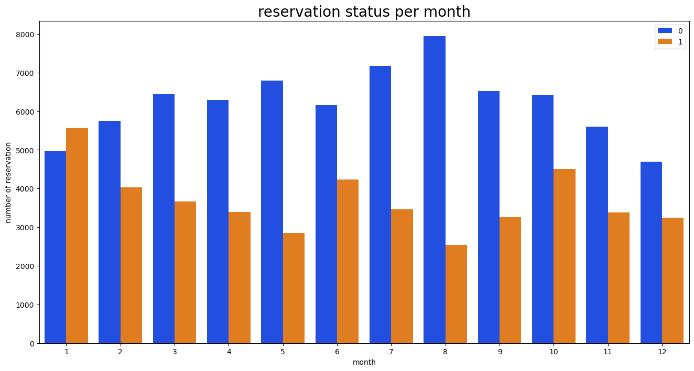

We have developed the grouped bar graph to analyze the month with highest and lowest reservation level according to reservation status as can be seen both the number of confirmed reservation and the number of cancelled reservation are largest in the month of august whereas January is month with most canceled reservations

***5. ADR for each month***

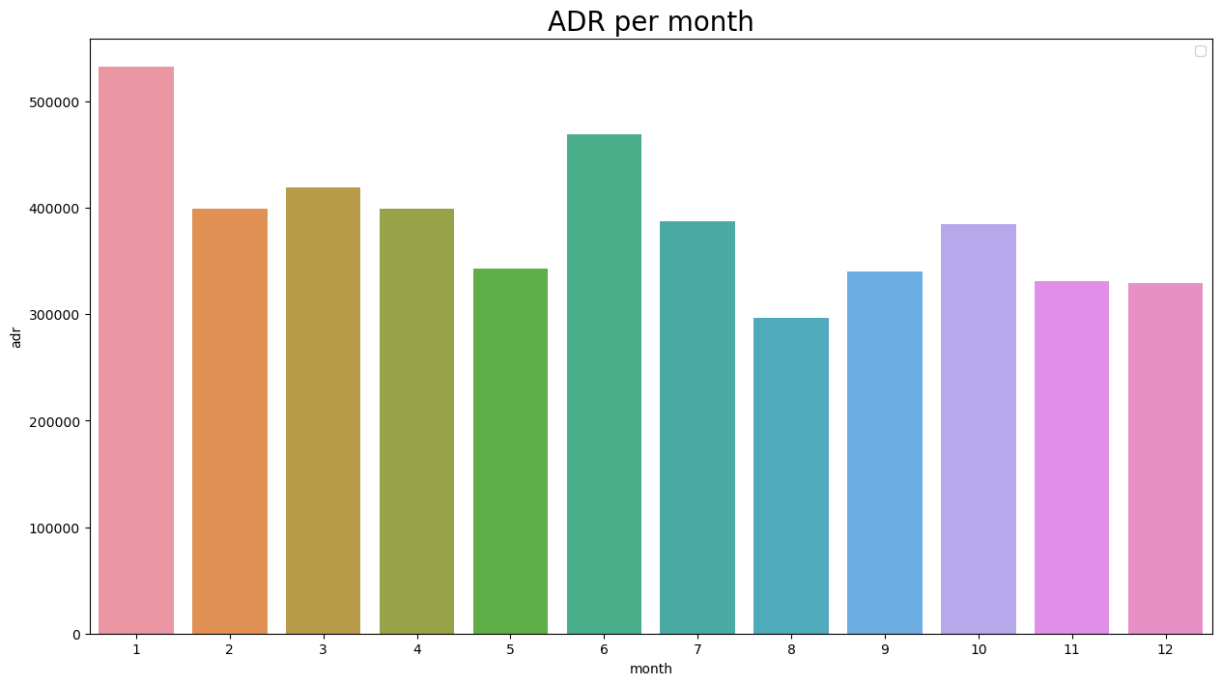This bar graph demonstrates that cancellations are most common when price are greatest and least common when they are lowest. therefore, the cost of the accommodation is solely responsible for cancellation

Now let’s see which country has highest reservation canceled the top country is Portugal with the highest number of cancellations

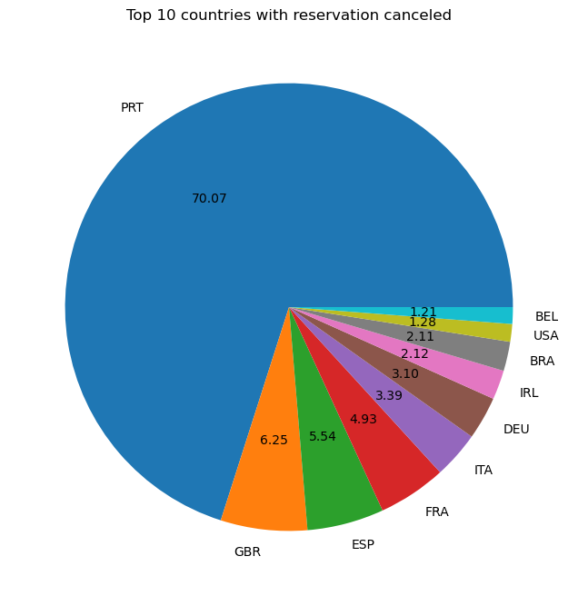***6. top countries with reservations cancelled***

Let’s check the area from where guest are visiting the hotel and making reservation. Is it coming from direct or group. online or offline travels agent around 46% of the clients come from online travel agents. whereas 27% come from group only 4 % of clients book hotel directly by visiting them and making reservation

***7. average daily rate***

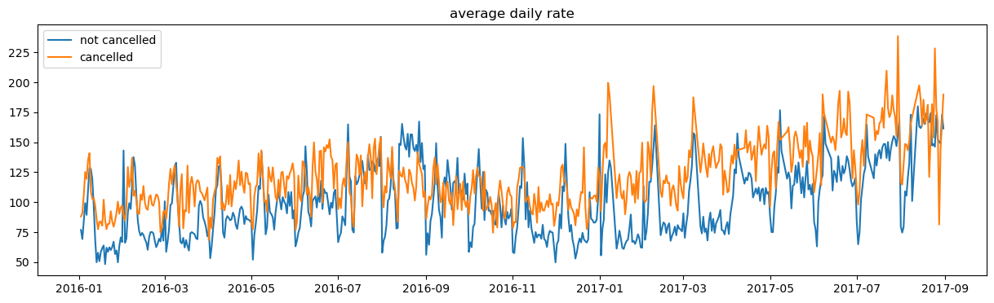As seen in graph reservation are cancelled when daily rate is higher that when it is not canceled it clearly proves all the above analysis that are the higher price lead to higher cancellations.

***SUGGETIONS***

**1.cancellation rate as the price does. In order to prevent cancellations o reservation hotel could work on their pricing strategies and try to lower the rate for specific hotel based on location they can also provide discounts to consumer.**

**2.as the ratio of the cancellations and not cancellation of resort hotel is higher in the resort hotel that city hotel so the hotel should provide reasonable discounts on the room’s prices on weekends or on holidays.**

**3.in the month of January hotel can start campaigns or marketing with a reasonable amount to increase their revenue as the cancellation is highest in this month**

**4.they can also increase the quality of their hotels and their service mainly in Portugal to reduce the cancellation**